11th UNCFSP/NLM HBCU ACCESS Meeting
“HBCU and Community
Partnerships in Health Information Access”

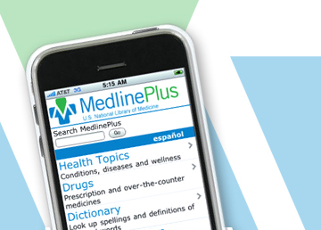

UNCF Special Programs Corporation is proud to collaborate with the National Library of Medicine to host this important meeting on information technology and partnerships in health today. The event will serve as an opportunity for a diverse group of health professionals, administrators, educators, librarians and representatives of HBCUs to gather and share current research; hear about the outcomes and impacts of the ACCESS Project from awarded campus-community teams at HBCUs; discover new funding opportunities, with the release of the new ACCESS Project 2012-2013 Request for Proposals*; and, learn how to advance access to and use of NLM online resources to improve health literacy on your campuses and in African-American communities.
Date: June 11-13, 2012

Venue: DoubleTree by Hilton, Bethesda, MD

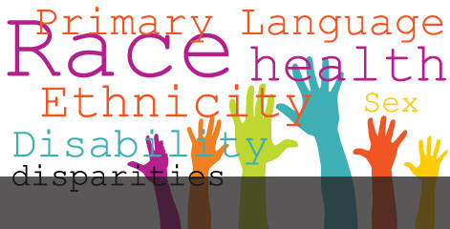

Meeting agenda and details regarding online registration: COMING SOON!
For additional information please contact: Renee Burgess at renee.burgess@uncfsp.org or 703-205-6585

