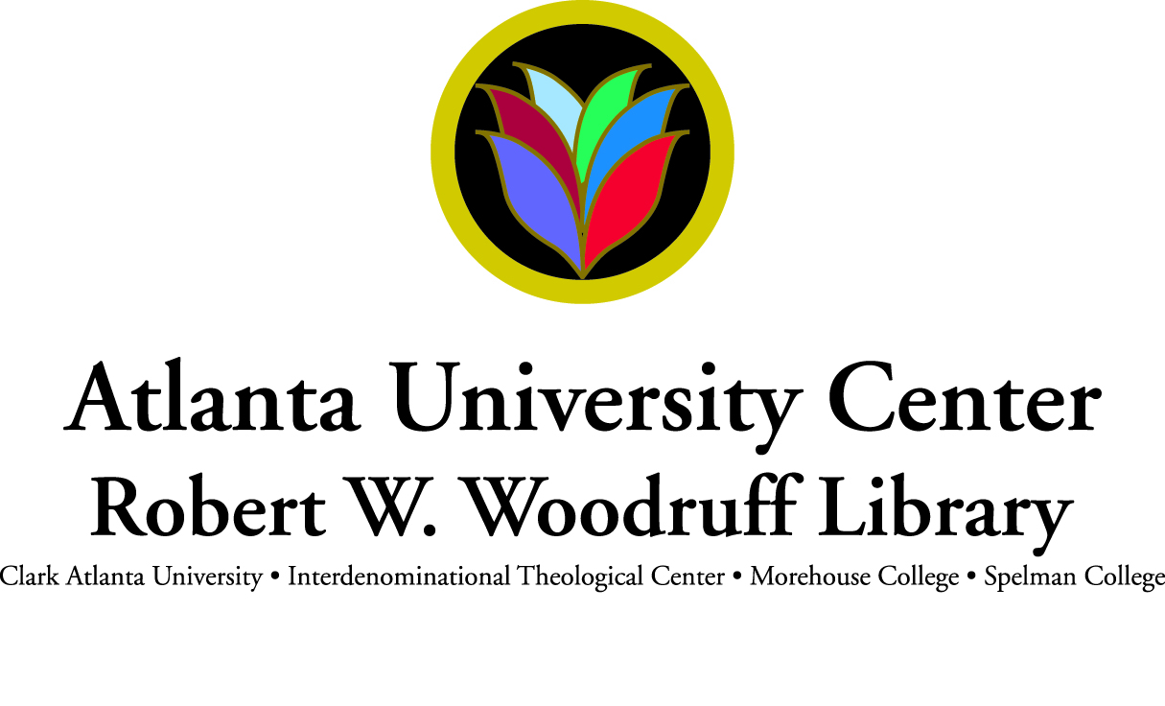

**POSITION ANNOUNCEMENT**

**JOB Title: E-Learning Technologies Librarian**

**DEPARTMENT: Discovery and Access**

[**www.auctr.edu**](http://www.auctr.edu)

**The Atlanta University Center - Robert W. Woodruff Library** supports the teaching and learning missions of four institutions of higher learning that comprise the world’s largest consortium of HBCUs—Clark Atlanta University, the Interdenominational Theological Center, Morehouse College, and Spelman College.  Conveniently located and easily accessible to the campuses, the Woodruff Library is the center of the intellectual and social life at the Atlanta University Center.

The Woodruff Library’s impressiveness is not limited to its physical environment. Our employees work to ensure that the Woodruff Library is an efficient and effective learning environment. Librarians offer engaging information literacy and instruction programs, working closely with faculty to develop expansive and relevant print and electronic collections. The library provides strategic support to our member institutions with focus on instruction, preservation, programming, support of curriculum and access to resources. Electronic resources are accessible via the Library's 230 public workstations and remotely through our website, [www.auctr.edu](http://www.auctr.edu/).  The Archives Research Center is a noted archive with more than 7000 linear feet of special collections. In addition, at the request of Morehouse College, the Library has served as custodian of the Morehouse College Martin Luther King Jr. Collection since September 2006. As such, the Library houses and oversees the security, conservation, preservation and access of the collection for scholarly research.

**SUMMARY:**

**The AUC Woodruff Library’s** “2010-2015 Strategic Plan: Building a 21st Century Learning Community – Advancing the Academic Village,” places emphasis on five priority areas: greater integration and partnership with our member institutions; strategic communications and marketing; quality learning and instruction; innovative learning technology; and increased resource development.

To meet its strategic goals, the library is re-engineering its functional units. Tools and resources are being employed to enhance learning experiences, pedagogical methods and curriculum. As part of this strategic implementation process, the Information and Research Services Department has been restructured and renamed. The Discovery and Access Department (D&AD), continues its focus on reference and research consultation, instruction, outreach and selection. The department is also positioned to create a learning environment that merges current learning strategies and new technologies to transform library instruction.

The **RWWL-AUC** seeks and innovative, energetic and experiencedE-Learning Technologies Librarian. This newly created position will work collaboratively with faculty, students and library staff to support effective use and inclusion of current and emerging learning technologies, multimedia applications, and library resources into teaching, research and study. This position is responsible for planning and implementing an integrated teaching and technology curriculum that will incorporate classroom, small group, individual, and online learning components. The E-Learning Technologies Librarian is responsible for the library's virtual existence on social media platforms, including establishing, monitoring, and entering communications that promote the library, its programs and resources. The E-Learning Technologies Librarian will participate in providing information and research services, in collection development and will serve as liaison to one or more academic departments within the Atlanta University Center. This position supervises 3 FTE and reports to the Head, Discovery and Access.

**Essential Duties and Responsibilities:**

* Hires, trains, coaches, and evaluates 3 staff FTE
* Identifies, implements, and promotes innovative online tools and services for both on-campus and off-campus learners
* Collaborates in the support and training of AUC faculty, staff, students and library staff in the use of new learning technologies
* Establishes, monitors, and enters communications that promote the library, its programs and resources via social media
* Assists faculty in the use of technologies for lessons and instructional modules
* Collaborate with AUC faculty and library staff to develop course websites with creative and instructional visuals and other instructional technology projects
* Creates and maintains training and end-user support content for instructional delivery tools
* Provides technical expertise to faculty who are integrating technology and library resources into traditional, online and hybrid courses
* Produces digital learning objects that are interactive, pedagogically sound, engaging to students, and facilitates the integration and use of library resources in course management systems and other online environments.
* Creates informational and promotional materials with a focus on design and visuals
* Monitors trends in emerging technologies and instructional design and identifies possible uses in library services

**Qualifications:**

* Demonstrated ability to create web-based instructional tools and other web-based resources
* Demonstrated knowledge of and experience with multimedia design and production, online course management systems, and technical writing and editing
* Demonstrated knowledge of and experience with using presentation tools (e.g. TechSmith, Camtasia, MS PowerPoint)
* Demonstrated knowledge of and experience with using production tools (e.g. Adobe Creative Suite, Apple iTunes U, Apple Final Cut Pro, Audacity)
* Demonstrated knowledge of and experience with using web development technologies (HTML, Flash, CSS, Java Script, Action Script)
* Demonstrated knowledge of information literacy concepts and applications
* Experience with reference services
* Experience in teaching library instruction classes in an academic environment
* Ability to work in both PC and Apple environments
* Ability to work independently and as part of a team, and to work with diverse populations

**Education / Experience:**

* MLS/MLIS degree from ALA –accredited institution
* Degree or certification in instructional design, educational technology or related field with demonstrated experience in applying the underlying theories of instructional technology; or an equivalent combination of education and experience
* Teaching experience
* Supervisory experience
* Two years experience working in an academic library

**SALARY & BENEFITS:**

Salary commensurate with experience; benefits include medical, dental, vision, life, company paid disability plans, company match retirement plan (TIAA-CREF).

**APPLICATION PROCEDURE:**

Interested applicants should submit a letter of application and resume online to the Human Resources Department at [careers@auctr.edu](mailto:careers@woodruff.edu).  Please include three professional references and salary requirements.  **Application review begins April 2012 and will continue until position is filled.**

The Robert W. Woodruff Library is an Equal Opportunity Employer. To learn more about our Library visit us online at [www.auctr.edu](http://www.auctr.edu/).