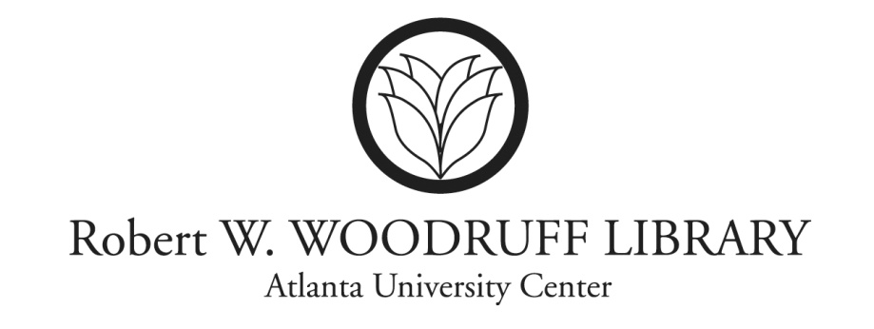

August 31, 2012

Dear HBCU Library Dean/Director:

The Atlanta University Center Robert W. Woodruff Library, in collaboration with the Council of Past HBCU Presidents, is conducting an oral history project, “**Documenting the Perspectives of the Council of Past HBCU Presidents**.” The project will publish and preserve documentation about the leadership and influences that selected HBCU presidents have had on the development of HBCUs within the context of historical events and national policy.

A selected number of the members of the Past Presidents Council will be interviewed and the interviews will be enhanced with biographical sketches, photographs, a bibliography of writings, and a comprehensive list of *all* HBCU presidents since the inception of the institutions. From this information a monograph will be prepared and the supporting materials will be published and available on the website of the HBCU Library Alliance.

**Your assistance is requested to insure that your institution is *accurately represented* in the comprehensive list of presidents. We ask that you submit a listing of the names and tenure of all the presidents that have served at your college/university.**

***For Example:***

**ATLANTA UNIVERSITY –Chartered 1867, Opened 1869**

**Name**  **Presidency**

Mr. Edmund Asa Ware 1869-1888

Mr. Thomas H. Chase (Acting President ) 1885-1886

Mr. Horace Bumstead (Acting President) 1886-1887

Mr. Cyrus W. Francis (Acting President) 1887-1888

Mr. Horace Bumstead 1888-1907

Etc.

**Please email this information to Karen Jefferson by September 28, 2012.**  [**kjefferson@auctr.edu**](mailto:kjefferson@auctr.edu). You may also contact Ms. Jefferson by telephone at 404-978-2045.

Your contributions are important to the success of this important documentary effort to preserve the legacy of our institutions. Your support is needed and appreciated. Thank you!



Loretta Parham

CEO & Director

AUC Robert W. Woodruff Library

404-978-2018 [LParham@auctr.edu](mailto:LParham@auctr.edu)