
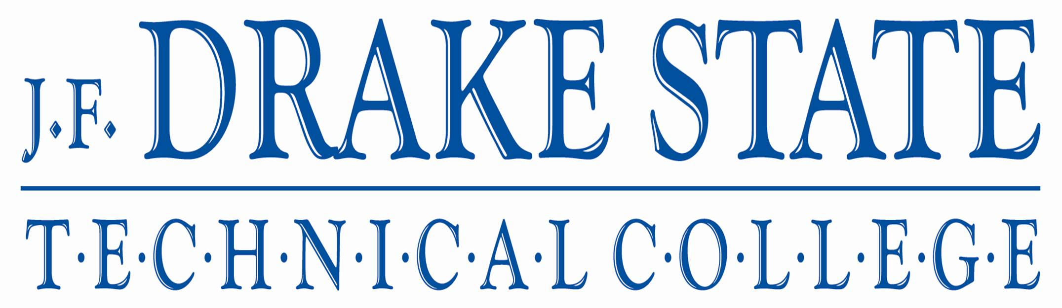

INTENT TO EMPLOY Post: 2-22-13

POSITION: ASSISTANT DIRECTOR OF LIBRARY SERVICES

QUALIFICATIONS:
- Minimum of a master’s degree in library science, media services, or a related field from an American Library Association accredited graduate school required.
- Three years of full-time work experience preferred.
- Excellent oral, auditory, and written communication skills preferred.
- Excellent organizational skills preferred.
- Ability to handle multiple tasks required.
- Ability to establish and maintain effective working relationships with students, other employees, and the public required.
- Ability to project a professional and congenial demeanor required.
- Ability to use information technology preferred.
- Demonstrated strong public service commitment preferred.
- Knowledge of core reference sources required.

DESIRED PROFILE:
- An understanding of and commitment to the philosophy and mission of a community and technical college.
- A sensitivity and commitment to cultural diversity.

The ability to handle multiple tasks and various situations in a calm, professional manner.
- A commitment to teaching and learning, particularly where adult students and non-traditional students are involved.

ESSENTAIL JOB FUNCTIONS:
The Assistant Director of Library Services shall perform the duties as specified in conformity with policies established by the Alabama State Board of Education and the J. F. Drake State Technical College Faculty and Staff Handbook.
- Assist the Director of Library Services in the delivery of comprehensive library services for students, faculty, staff, and other approved patrons.
- Requisition books, AV material and other educational material for the Learning Resources Center.
- Assist with the library instruction program.
- Provide general reference service in person and via telephone.
- Provide technical support to faculty development initiatives.
- Provide technical support for faculty and staff personnel involved in research projects.
- Instruct students in the proper usage of all library resources.
- Attend workshops, conferences, and seminars of professional growth and development.
- Provide maintenance and instruction for electronic resources including databases, eBooks, websites, and library software.
- Provide collection management and development.
- Provide original cataloging using Dewey Decimal System in a variety of formats and subject areas.
- Prepare journals for binding.
- Develop materials and teaching aids for the library instruction program.
- Solicit feedback from faculty to determine curriculum changes and needs for new library materials.
- Review literature to recommend additions to the collection.
- Assist with interpretation of all library policies and procedures.
- Maintain compliance with college and program related accreditation and certification standards.
- Retain and submit documentation as requested to support accreditation efforts.
- Assume other work related responsibilities as assigned by the Director of Library Services, Dean of Instruction, and/or President.

SALARY: Appropriate placement on Alabama State Salary Schedule D-1, Rank 1C
Salary Range $45,041 - $71,266

APPLICATION: Applicants must meet the minimum qualifications and must submit a completed
application packet in order to be considered for this position. Applicants who fail to submit all required documents by the deadline listed below will not be considered. A complete application packet includes:
- A completed and signed DSTC application.
- Current resume.
    - Official and sealed transcripts from all institutions where collegiate credit has been earned. Unofficial transcripts are acceptable for the application packet; however, any applicant making the second round of interviews and still missing “official transcripts”, will not be interviewed by the President. The application packet will be considered incomplete and the applicant will be disqualified.
    - Three signed letters of recommendation relevant to the position. Letters should be dated within the past three years, printed on letterhead of the signer’s organization, and have an actual signature (no computer generated signatures). One letter must be from a current or former supervisor which verifies required experience. Reference letters must be from different individuals than the three names listed in the “reference” section of the application

J. F. Drake State Technical College employment forms are available online at (www.drakestate.edu) or in the Office of Human Resources. The completed application packet should be returned to:
J.F. Drake State Technical College
Attn: Office of Human Resources
3421 Meridian Street, North
Huntsville, Alabama 35811
Telephone 256-551-5214

APPLICATION Monday, March 18, 2013 at 4:30 p.m.
DEADLINE:

ANTICIPATED
STARTING DATE: April, 2013

Applicants must adhere to the College’s prescribed interview schedule and must travel at his/her own expense. Employment will be contingent upon the receipt of a clearance notification from the criminal background check. J. F. Drake State Technical College is an active participant in the Employment Eligibility Verification Program (E-Verify). E-Verify electronically confirms an employee’s eligibility to work in the United States as required by the Department of Homeland Security.
______________________________________________________________________________________
J. F. Drake State Technical College is an equal opportunity employer. It is the official policy of the Alabama Department of Postsecondary Education, including postsecondary institutions under the control of the State Board of Education, that no person shall, on the grounds of race, color, handicap, gender, religion, creed, national origin, or age, be excluded from participation in, be denied the benefits of, or be subjected to discrimination under any program, activity, or employment. J. F. Drake State Technical College will make reasonable accommodations for qualified disabled applicants or employees. The college reserves the right to withdraw this job announcement at any time prior to awarding.

