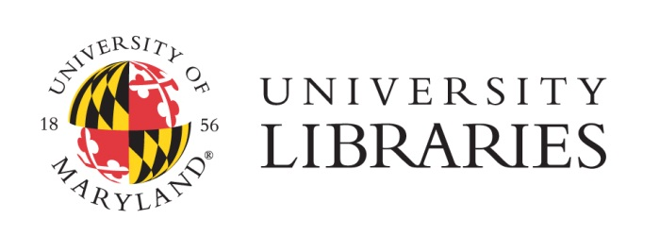

**Title:** Labor Collections Coordinator

**Category:** Exempt, Contingent 2 (Contractual)

**Department:** Special Collections, Collections Division, Libraries

**Benefits:** 22 Days Annual Leave, 15 Days of Sick Leave, 3 Days Personal Leave, 15 Paid Holidays

Tuition Remission, Health, Dental, Vision, and Prescription

As the largest university library system in the Washington D.C.-Baltimore area, the University of Maryland Libraries serve more than 37,500 students and 4,200 faculty of the flagship College Park campus. The University of Maryland Libraries share the teaching, learning and research goals of the university. Its role as a key academic resource is evident in its service to the academic community and its actionable strategic plan. Recent membership in the Committee on Institutional Cooperation, a robust organization of Big Ten member institutions, is particularly meaningful to the University Libraries and will further propel the university’s ascendancy in academic excellence.

The University of Maryland Libraries is seeking dynamic applicants for the position of Labor Collections Coordinator. The position is a one year contract that is renewable and is expected to be for 2 yrs. The successful candidate will assist with reference services and collection development related to all labor collections holdings in Special Collections, including the AFL-CIO archives. These rich labor collections encompass the history of labor in North America, national and international labor unions, as well as Maryland-related labor movements and issues. Particular collection strengths include, but are not limited to, the AFL-CIO; the Industrial Union of Marine and Shipbuilding Workers of America; the Bakery Confectionary, Tobacco Workers and Grain Millers; the Cigar Makers International Union; and the United Brotherhood of Carpenters and Joiners of America. With the recent acquisition of the AFL­ CIO archives, the University of Maryland Libraries has established a premier collection for labor research.

The Labor Collections Coordinator is primarily responsible for managing the accessioning, processing, arrangement, description, and retention and disposition schedules for the AFL-CIO archives and additional labor collections within Special Collections. The collections coordinator takes a leading role in establishing, communicating, and ensuring proper records management practices, schedules, and requirements with AFL-CIO and labor union officers, members, and others. The successful candidate will thrive in a collaborative environment within Special Collections and within the University of Maryland Libraries.

**Requirements for the position:**

* Bachelor's degree with experience in archives, archival course work, or archival certificate .
* At least two years of prior work experience in an archival repository or records management setting.
* A thorough understanding of archival principles, practices and archival processing, including the ability to evaluate materials as to historical value.
* Experience in finding aid preparation; and familiarity with electronic access tools including HTML, Encoded Archival Description (EAD), and MARC records.
* Experience with MS-Excel, MS-Access, or other database management and spreadsheet software.
* Excellent oral and written communications skills and an ability to work independently and collegially.
* Public service skills, including work experience at a reference desk in an archives or special collections setting.

**Preferred:**

* ALA-accredited master's degree in library science with an emphasis on formal archival education and training and/or records management
* Experience working with special collections related to labor history.
* Prior experience supervising student assistants, volunteers, and support staff.

For the full position description, please go to <http://www.lib.umd.edu/hr/employment-opportunities/staff-faculty-positions>.

**APPLICATIONS:** Electronic applications required. Please apply online at <https://ejobs.umd.edu/postings/24038>. No relocation assistance will be provided. You must be legally able to work in the United States; the University of Maryland Libraries will not sponsor individuals for employment. An application consists of a cover letter which includes the source of advertisement, a resume, and names/e-mail addresses of three references**.**

Applications will be reviewed as they are received and accepted until **February 14, 2014**.

The University of Maryland, College Park, actively subscribes to a policy of equal employment opportunity, and will not discriminate against any employee or applicant because of race, age, sex, color, sexual orientation, physical or mental disability, religion, ancestry or national origin, marital status, genetic information, political affiliation, or gender identity and expression.  Minorities and women are encouraged to apply.