The Director of Library Services at Johnson C. Smith University is one of the contributing writers to ACRL new publication, “*Creating Leaders: An Examination of Academic and Research Library Leadership Institutes*. Edited by Irene M. H. Herold, and featuring a foreword by Maureen Sullivan, the work focuses on leadership development programs for academic and research librarians. *Creating Leaders: An Examination of Academic and Research Library Leadership Institutes* is available for purchase in print, as an e-book, and as a print/ e-book bundle through the ALA Online Store; in print and for Kindle through Amazon.com; and by telephone order at (866) 746-7252 in the U.S. or (770) 442-8633 for international customers.

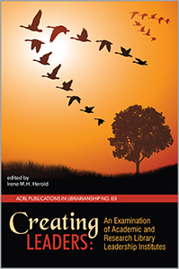Mrs. Rhue’s chapter focused on the HBCU Library Alliance Leadership Institute. The HBCU Library Alliance Leadership Institute goal was to provide an environment to assist HBCU librarians to: “articulate and advance a vision for the library as a valued partner in the teaching and learning; manage change that will transform the library into a ‘learning commons;’ build partnerships with faculty and administrators and with the broader HBCU community; and create a culture of leadership within the library staff.” Mrs. Rhue shared the overall success of the program, highlights of the program and further opportunities for research and expansion. Mrs. Rhue also shared briefly her participation in the Harvard Leadership Institute for Academic Librarians. Her final comments acknowledged that both leadership institutes provided her with a foundation of resources for evaluating her leadership type, capabilities, and how to shape and mold her leadership style from various lenses when dealing with the complexities of personalities, implementing change, and receiving buy-in from employees to administrators during the implementation of new initiatives.

Mrs. Rhue is also the author of *Organizing and Preserving Family and Religious Records: A Step-by-Step Guide, and Dress the African Way: An Activity Book for the Family.* Both books are available through Amazom.com.