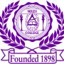 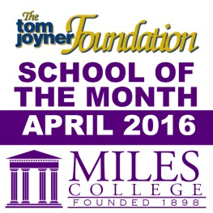

***NEWS RELEASE***

**Media Contact:**

**Alicia Johnson-Williams**

**Director of College Relations**

**(205) 515-7781**

**E-mail:** [**ajwilliams@miles.edu**](mailto:ajohnson@miles.edu)

**FOR IMMEDIATE RELEASE**

**April 5, 2016**

**MILES TO MICHIGAN**

***Sponsored by the Miles College Quality Enhancement Plan (QEP)***

**Fairfield, Ala. -** Miles College Quality Enhancement Plan faculty and staff are sponsoring a Water Drive, Wednesday, April 6 – Friday, April 8, 2016, 8:00 a.m. – 2:00 p.m. Drop Off location is the Campus Front Entrance (Myron Massey Boulevard).

A Campus Forumwill also be held Wednesday, April 6, 2016 in Brown Hall at 11:00 a.m. Debra Love of E3 Solutions will be the guest speaker.

For more information contact the QEP office at 205-929-1755 or email [nwinters@miles.edu](mailto:nwinters@miles.edu).

###