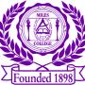 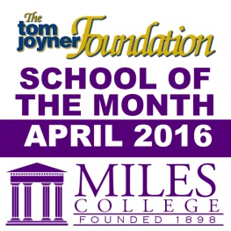

***NEWS RELEASE***

**Media Contact:**

**Alicia Johnson-Williams**

**Director of College Relations**

**(205) 515-7781**

**E-mail:** [**ajwilliams@miles.edu**](mailto:ajohnson@miles.edu)

**FOR IMMEDIATE RELEASE**

**April 14, 2016**

**Miles College Theatre Program Presents *A Song for Coretta***

**Fairfield, Ala. –** Miles College Theatre Program presents *A Song for Coretta* by Pearl Cleage, directed by Chalethia Williams on Friday, April 22, 2015 at 7:30 p.m. and Saturday, April 23, 2016 at 7:30 p.m. in The Rev. Dr. Abraham Woods, Jr. Auditorium, Pearson Hall.

The story begins on February 6, 2006, when people start lining up at dawn outside of Atlanta’s Ebenezer Baptist Church to pay their respects to the late Mrs. Coretta Scott King, widow of Dr. Martin Luther King, Jr., whose body lay in state in the small sanctuary. People of all ages stood patiently for hours, waiting to say goodbye and close to midnight, the crowd had dwindled to a determined few. Throughout the day they shared memories of Mrs. King’s extraordinary life and expressed sorrow at her passing.

Theatre majors Camellia J. Brownlee, Priscilla Bridges, Raven Cook-Smith, Demetria A. Collins, and Lisa M. Clemons portray the five fictional characters at the end of that long line of mourners.

Tickets are $10.00 each and groups of 10 or more $8.00 each. For more information contact

Ms. Chalethia Williams 205.929.1052 or [cwilliams@miles.edu](mailto:cwilliams@miles.edu) or Mrs. Sandra Crenshaw

205.929.1659 or [crenshaw@miles.edu](mailto:crenshaw@miles.edu).

###