**Get Your Miles College License Plate Today!**

You can get the new Miles College license plate by visiting [AL MVD website](http://revenue.alabama.gov/motorvehicle/collegeview.cfm).

These plates are **available to anyone** and usually cost $50 per year **IN ADDITION** to your [registration fees](http://www.dmv.org/al-alabama/car-registration.php#Alabama-Vehicle-Registration-Fees). These fees are used to fund **scholarship programs at Miles College**.

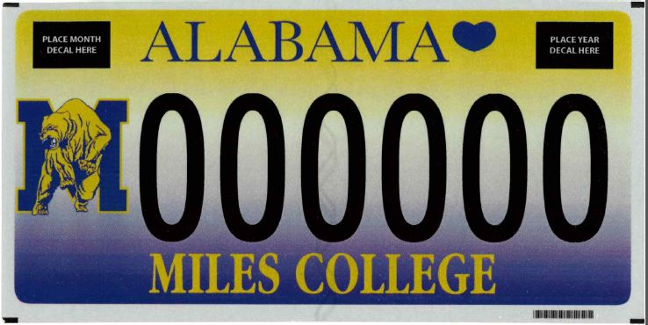

**Who may purchase license plates in this category?** All residents of Alabama who are vehicle owners and supporters of Miles College.

**Is there any documentation required to be presented by the registrant prior to purchasing this plate?** No

**What registration fees are associated with the purchase of this license plate?** $23.00- $890.00 depending on the type of vehicle being registered

**May the plates be personalized?** Yes

**Additional fees:** $50.00 for pre-numbered or personalized plate

**How often are the additional fees paid?** Annually

**Are plates in this category transferable? If so, to whom?** Yes. If a motor vehicle is transferred to the transferor's spouse or child, at the option of the transferor, the license plate may remain on the vehicle in the hands of the transferee upon payment of the fee for recording the transfer of the license plate. The transfer fee is $1.25.

**What type of vehicles may this plate be displayed upon?** Private passenger automobiles, pickup trucks, and pleasure motor vehicles (i.e., recreational vehicles)

**How are the net proceeds from the purchase of this plate distributed?** The net proceeds are distributed to the general scholarship funds of the college or university whose tag is purchased for scholarship grants to Alabama resident students only. These fees represent a charitable contribution from the purchaser to the general scholarship fund of that institution.