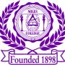 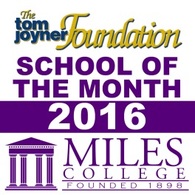

***NEWS RELEASE***

**Media Contact:**

**Alicia Johnson-Williams**

**Director of College Relations**

**(205) 515-7781**

**E-mail:** [**ajwilliams@miles.edu**](mailto:ajohnson@miles.edu)

**FOR IMMEDIATE RELEASE**

**May 25, 2016**

# Miles College Flaunts New License Plate

**Fairfield, AL** - Miles College has a new license plate available for purchase through the Alabama Department of Motor Vehicles. A portion of the proceeds from the sale of the new plate will benefit the College.

The new plate features the image of the “M-Bear” also known as the Miles College *Golden Bear*.

“Everyone is pleased with the design,” said President French. “It has received great reviews from our Alumni.”

It’s colorful and contemporary design will make Mileans proud to display their Golden Bear Spirit by purchasing this new plate.

Interested parties can get the new Miles College license plate by visiting [AL MVD website](http://revenue.alabama.gov/motorvehicle/collegeview.cfm).

These plates are available to anyone and usually cost $50 per year in addition to the standard [registration fees](http://www.dmv.org/al-alabama/car-registration.php#Alabama-Vehicle-Registration-Fees).

###