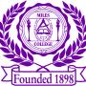 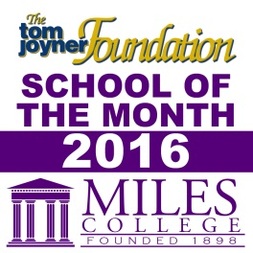

***NEWS RELEASE***

**Media Contact:**

**Alicia Johnson-Williams**

**Director of College Relations**

**(205) 515-7781**

**E-mail:** [**ajwilliams@miles.edu**](mailto:ajohnson@miles.edu)

**July 22, 2016**

**FOR IMMEDIATE RELEASE**

**Labor Day Golden Classic 2016**

**Fairfield, Ala. -** The Labor Day Golden Classic returns to Legion Field Sunday, September 4, at 4:00 p.m. The Miles Golden Bears take on Fort Valley State University.

Five student-athletes were named to the Preseason All-Conference team. The Golden Bears were picked to finish first in the West Division. “We are happy to bring an exciting quality event to our alumni, our fans and the city of Birmingham,” Miles College Athletic Director Phillip Wallace Jr. said.

For ticket information call 205-929-1732. Make checks payable to Miles College,

P.O. Box 39800, Birmingham, AL 35208.

**When:** Sunday, September 4, 2016

**Where:** Legion Field

**Time:** 4:00 p.m.

###