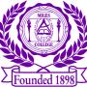 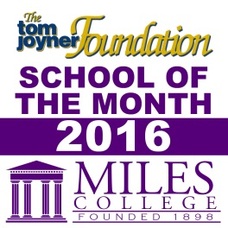

***NEWS RELEASE***

**Media Contact:**

**Alicia Johnson-Williams**

**Director of College Relations**

**(205) 515-7781**

**E-mail:** [**ajwilliams@miles.edu**](mailto:ajohnson@miles.edu)

**August 16, 2016**

**FOR IMMEDIATE RELEASE**

**Tickets Available Now for the Labor Day Golden Classic!**

**Fairfield, Ala. -**The Miles College Labor Day Golden Classic is back! Tickets are available for the season-opening football game which takes place on Sunday, September 4, 2016, at 4:00 p.m. between the Miles College Golden Bears and the Fort Valley University Wildcats at historic Legion Field.

Fans who want to attend the game can take advantage of the Early Bird discount on Thursday, August 18, 2016 from 11:30 a.m. to 2:30 p.m. Tickets will be $15 on the beautiful Campus of Miles College at the Sloan-Alumni Stadium ticket booth or at the Legion Field ticket booth.

$15 Early Bird tickets One-Day Only.

###