[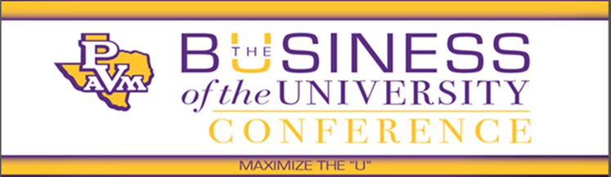](http://www.pvamu.edu/businessaffairs/bouc/)

**Powerful Insights, Proven Expertise, and Substantive Results**

On behalf of NACUBO, SACUBO, and Prairie View A&M University, we are pleased to invite you and your staff to the inaugural [Business of the University Conference](http://www.pvamu.edu/businessaffairs/bouc/) in Houston, TX, November 9-11. The focus of the conference centers on the challenges and opportunities faced by minority-serving and small institutions.

Participation in the conference will afford you the opportunity to build the connections and knowledge base to assist your institution in reinventing itself for the new era in higher education. You will learn about innovative and disruptive approaches and strategies that prioritize the needs of today’s and tomorrow’s students.

The conference planning team has developed a dynamic program inclusive of knowledge sharing, professional development, networking opportunities, and (you guessed it) fun! Our distinguished panel, which hails from across the higher education landscape, offer timely and relevant sessions on pertinent topics inclusive of:

* Exploring the Chief Business Officer’s Role in Using Innovation to Accelerate Institutional Outcomes
* Using Public-Private Partnerships (P3) as a Competitive Advantage
* The Sponsor Effect: Pushing, Pulling, & Promoting You
* Streamlining/Re-Engineering Processes for Effectiveness and Efficiencies
* Using Leadership Development as a Tool for institutional Transformation

Your presence at the conference is important to us as we assist each other in maximizing the potential of our students and our Universities—**Maximize the “U”**. We look forward to seeing you there.

[**Learn more and register today!**](http://www.nacubo.org/Events_and_Programs/2016_PVAMU_The_Business_of_the_University_Conference.html)

**Sponsored by:**

