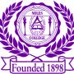**Media Contact:**

**Alicia Johnson-Williams**

**Director of College Relations**

**(205) 515-7781**

**E-mail:** [**ajwilliams@miles.edu**](mailto:ajohnson@miles.edu)

**NEWS RELEASE**

**FOR IMMEDIATE RELEASE: January 24, 2016**

**Miles College Purple Marching Machine Voted HBCU Sports Band of the Year**

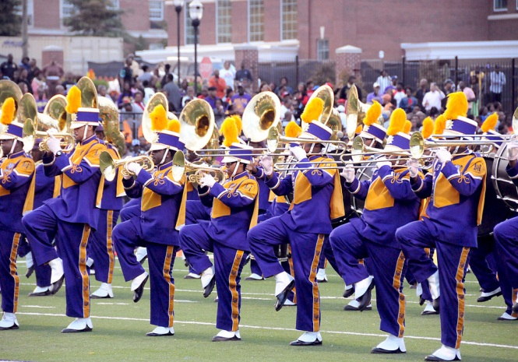**Fairfield, Ala.** –The Miles College Purple Marching Machine was voted Historically Black Colleges and Universities (HBCU) Sports Band of the Year on Saturday, January 21, 2017.

In the HBCU Sports Band fan survey, which included five finalists and produced more than 43,000 votes, Miles College finished the rundown with (18,955 votes) 44 percent of the aggregate vote. Alabama A&M completed second in the survey with (12,634 votes) 29.29 percent of the aggregate vote, trailed by Jackson State (5,125), North Carolina A&T (4,977 votes) and Southern (1,402 votes).

Mr. Iva "Bossman" Williams began the Miles College Band Program in 1949 with thirty-five individuals. Today, band participation at Miles College has developed to more than 200 individuals. The Purple Marching Machine is one of the largest and most dynamic organizations at Miles College having performed as an exhibition band for many Marching Band Festivals and receiving many accolades.

PMM has performed for President William “Bill” Clinton’s Campaign Rally at Birmingham Southern College, was selected to perform in the Inaugural Pioneer Bowl, and in October 2000, performed in Atlanta, Georgia in the first Historically Black Colleges and Universities Band Extravaganza, performed in the 2002 Macy’s Thanksgiving Day Parade in New York City, was invited to perform the Atlanta Falcons vs. Chicago Bears halftime show in 2014, won the 2015 Queen City Battle of the Bands in Charlotte, NC, was featured in the Hillary Clinton’s Democratic campaign in spring 2016, voted HBCU band of the week in week 9, received No. 2, No. 6, and No. 16 rankings in top 20 cover songs of 2016 by HBCU Bands, and ranked in the top 10 halftime shows of 2016 by HBCU Bands just to name a few.

Currently under the direction of Dr. Willie James Snipes, Jr., the Purple Marching Machine remains one of the premier bands in the nation.

Prior to becoming Head Band Director at Miles College, Mr. Snipes has had an extensive career in band and music. Whiles attending Woodlawn High School in Birmingham, Alabama he became student director in 1999 and was named Most Outstanding Band Member in 2000. Later attending Miles College, he was exceptionally dynamic in the band, taking part in the marching band, pep band, concert band and jazz band. Additionally, he became a student director at Miles College, assisting with band camps, managing the band’s budget, drill writing, arranging, and conducting music for the band. Mr. Snipes was the first alum to receive a degree in music from Miles College.

Snipes currently serves as Vice President of the SIAC Band Directors Board, Kappa Psi, and a member the music organization Phi Mu Alpha Sinfonia.

###