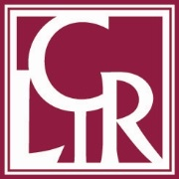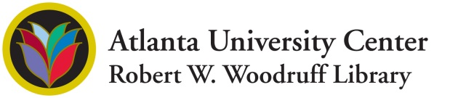

Contact: Trina Megginson, [tmegginson@auctr.edu](mailto:tmegginson@auctr.edu), 404.978.2114

**AUC WOODRUFF LIBRARY SHARES IN $4 MILLION AWARD TO DIGITIZE RARE AND UNIQUE COLLECTIONS DOCUMENTING 132 YEARS OF AUC HISTORY**

***The AUC Robert W. Woodruff Library, in partnership with the Digital Library of Georgia, Morehouse College and Spelman College receives generous backing to participate in Digitizing Hidden Collections program of the Council on Library and Information Resources (CLIR).***

**ATLANTA, GA - February 7, 2017** – The AUC Woodruff Library is one of 17 institutions to receive funding from CLIR to expand the reach of the AUC’s unique publications, periodicals, theses, dissertations and photographs that document the rich history of the nation’s largest consortium of Historically Black Colleges and Universities (HBCUs). The total awarded to AUC Woodruff Library was $447,078.

“*Our Story: Digitizing Publications and Photographs of the Historically Black Atlanta University Center Institutions”* is a 30-month project which will begin this year and end in 2020. Project partners, including AUC Woodruff Library, Morehouse College and Spelman College Archives will contribute content, serve on the project planning team and assist with outreach and promotion of the digital collections. Once completed, archives related to past and present AUC schools (Atlanta University, Clark College, Clark Atlanta University, Gammon Theological Seminary, Interdenominational Theological Center, Morehouse College, Morris Brown College and Spelman College) will be more easily discoverable for learning about various aspects of African American higher education from emancipation of slavery through the 21st century.

**Over the course of the project, more than 700,000 items will be digitized and made available online to ensure resources are easily accessible for the purpose of scholarship and research.** Project staff at the Digital Library of Georgia will create the metadata, prepare the newspaper database and upload content to the Digital Library of Georgia’s online portal. “The impact of digitizing exceptional collections is infinite, and we deeply appreciate the Council on Library and Information Resources for funding this project that will ensure the accessibility of the AUC’s rich and invaluable history for generations to come,” says Loretta Parham, CEO and Director. Deliverables produced by the project will be widely promoted through the Internet, blog, social media, in research guides (LibGuides), at conferences and in scholarly publications.

CLIR is an independent, nonprofit organization that forges strategies to enhance research, teaching, and learning environments in collaboration with libraries, cultural institutions, and communities of higher learning. CLIR’s Digitizing Hidden Collections program is generously funded by The Andrew W. Mellon Foundation. The program provides institutions the means to enhance their global digital research environment in ways that support innovative scholarship for the long term, ensuring that the full wealth of resources held by the institution becomes integrated with the open Web.

**About the Library**

Established in 1982, the Atlanta University Center Robert W. Woodruff Library is a shared resource supporting a consortium of four independent Historically Black Colleges and Universities (HBCUs)– Clark Atlanta University, the Interdenominational Theological Center, Morehouse College and Spelman College. Each of these prestigious schools comprising the AUC has a unique academic culture steeped in history, tradition and excellence. The Library is a nonprofit corporation under the Georgia Nonprofit Corporation Code and operates exclusively for educational and charitable purposes as defined in Section 501(c)3 of the IRS Code. It is governed by a ten-member Board of Trustees.

###