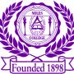**Media Contact:**

**Alicia Johnson-Williams**

**Director of College Relations**

**(205) 929-1000**

**E-mail:** [**ajohnson@miles.edu**](mailto:ajohnson@miles.edu)

***NEWS RELEASE***

**FOR IMMEDIATE RELEASE:**

**April 24, 2017**

**Miles College Announces Veteran Democratic Political Strategist Donna Brazile as Commencement Speaker**

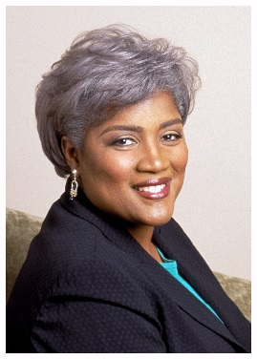**Birmingham, AL** – Veteran Democratic political strategist and former Chair of the Democratic National Committee, Donna Brazile will be the speaker for this year’s Miles College Commencement ceremony, Saturday, May 6, 2017 at 11 a.m., at the Boutwell Auditorium. Approximately 247 graduates are in the Miles College Class of 2017.

“We are honored that Donna Brazile will speak at our Commencement this year," said President French. "As a respected and outspoken community advocate and political leader, Ms. Brazile has a front-row view of the country's evolving educational, social justice and political current and future climate. We welcome her to share words of wisdom and encouragement with our 2017 graduating seniors."

Ms. Brazile is the former Vice Chair of Civic Engagement and Voter Participation at the DNC and former chair of the DNC’s Voting Rights Institute. Ms. Brazile is also an as an adjunct professor at Georgetown University, Ms. Brazile is the author of the best-selling memoir *Cooking with Grease: Stirring the Pots in American Politics* and is on leave with ABC News. She is especially pleased to have made three cameo appearances on CBS’s *The Good Wife,* and two cameo appearances on Netflix’s series *House of Cards.* She most recently appeared on BET's *Being Mary Jane*. Ask her and she’ll tell you that acting, after all, is the key to success in. She is currently on the board of the National Democratic Institute (NDI), the Congressional Black Caucus (CBC) Foundation, and the Joint Center for Political and Economic Studies.

Ms. Brazile has worked on every presidential campaign from 1976 and in 2000 became the first African-American to manage a presidential campaign. Named among the 100 Most Powerful Women by *Washingtonian* magazine, Top 50 Women in America by *Essence* magazine, and received the Congressional Black Caucus Foundation’s highest award for political achievement. In 2016, Ms. Brazile was awarded Wonk of the Year from the Kennedy Political Union at American University.

A native of New Orleans, Louisiana, she is the recipient of honorary doctorate degrees from Louisiana State University, North Carolina A&T State University, Grambling State University, Spelman College, LeMoyne Owen College, Northeastern Illinois University, Medgar Evers College, Morehouse Medical College, Bethune Cookman University, Thomas Jefferson School of Nursing and Xavier University of Louisiana, the only historically Black, Catholic institution of higher education in the United States. Ms. Brazile is founder and managing director of Brazile & Associates LLC, a grassroots advocacy firm based in Washington, DC.

Members of the media who plan to attend, or need information regarding Commencement should contact Alicia Johnson Williams by email at ajwilliams@miles.edu or by phone at 205-515-7781.

###