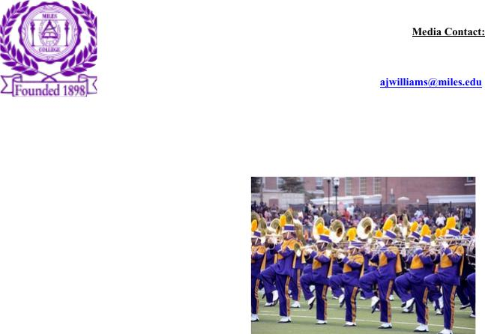Media Contact:

Alicia Johnson-Williams

Director of College Relations

(205) 515-7781

E-mail: ajwilliams@miles.edu

**NEWS RELEASE**

***FOR IMMEDIATE RELEASE:***

*April 4, 2018*

**Miles College to Compete in 29th Annual Honda Campus All-Star Challenge**

**Championship Tournament in Los Angeles, April 7-11**

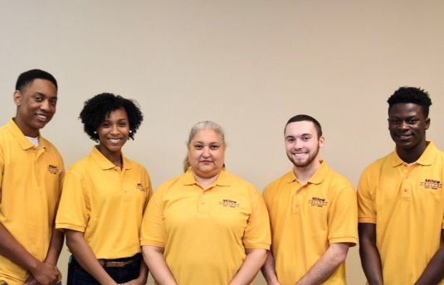

Fairfield, AL- After participating in a National Qualifying Tournament, Miles College will compete against fellow Historically Black Colleges and Universities (HBCUs) at the 29th annual Honda Campus All-Star Challenge National Championship Tournament (HCASC) April 7-11. Teams from 48 HBCUs will go head-to-head in the National Championship of America’s premier academic quiz for top HBCU student on the American Honda Motor CO., Inc. campus in Torrance, California. Miles College has the opportunity to win the HCASC top prize - a $75,000 institutional grant from Honda.

Miles will be represented by Marcus Goshey, a senior majoring in Computer Information Systems form Westwood, NJ, Keila Michelle Lawrence, a sophomore majoring in Biology from Savannah, GA, Colby Brent Pate, a sophomore majoring in Mathematics from Hueytown, AL, and Jordan Walker, a freshman majoring in Communications from Atlanta, GA. Misty Hardy McFadden is the coach for the team.

“This is a well-deserved opportunity for our students and their coach for achieving such greatness,” said Miles College President George T. French Jr. “I am very proud of them and I know they will continue to represent Miles College well as they compete for the National Championship.”

Honda Campus All-Star Challenge is a year-round program that includes campus engagement, intramural play, qualifying tournaments and culminates with the National Championship. The fast-paced competition highlights students’ academic prowess and ability to answer questions about history, science, literature, religion, the arts and pop culture. As a result, students expand their scope of knowledge; learn teamwork and sportsmanship; travel to California to represent their schools at the National Championship Tournament; and develop a bond with their fellow competitors. HCASC’s active alumni group also supports students with networking and mentorship opportunities post-graduation.

The 2018 HCASC finals will be live‐streamed on Tuesday, April 10 starting at 12:00 p.m. ET at HCASC.com. For more information on HCASC, including a full list of the 48 qualifying teams, visit [www.hcasc.com.](http://www.hcasc.com/)

###