**PRESS RELEASE**

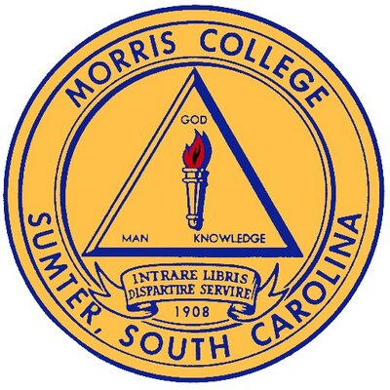

**CONTACT INFORMATION:**

**Office of the President**

**Communications Specialist**

**Andrea Butler**

**803-934-3271**

[**abutler@morris.edu**](mailto:abutler@morris.edu)

**MEDIA ADVISORY**

**March 12, 2020**

**Morris College to extend Spring Break; faculty and staff to report to work**

*Morris College extends Spring Break March 16-23*

As we continue to monitor the spread of the Coronavirus Disease (COVID-19), our first priority is the health, welfare, and safety of our students, faculty, staff and community. The Emergency Management Team continues to work closely with the South Carolina Department of Health and Environmental Control and Centers for Disease Control. Effective immediately:

* Spring Break will be extended for the week (March 16 – 23) and no classes will be held.
* All campus events from March 16 -23 will be canceled.
* Residence halls will reopen Monday, March 23 at 8:00 a.m., classes will resume at 10:00 a.m.
* All athletic events scheduled for the week (March 16 -23) will be canceled.
* All faculty and staff are required to report to work during this time (March 16-23).

We at Morris College understand that the coronavirus is an evolving global situation and we strongly encourage you to stay abreast of updates by visiting the COVID-19 link on our website. This is a rapidly changing health issue and we will continue to provide updates as quickly as possible when additional information becomes available.

**###**